

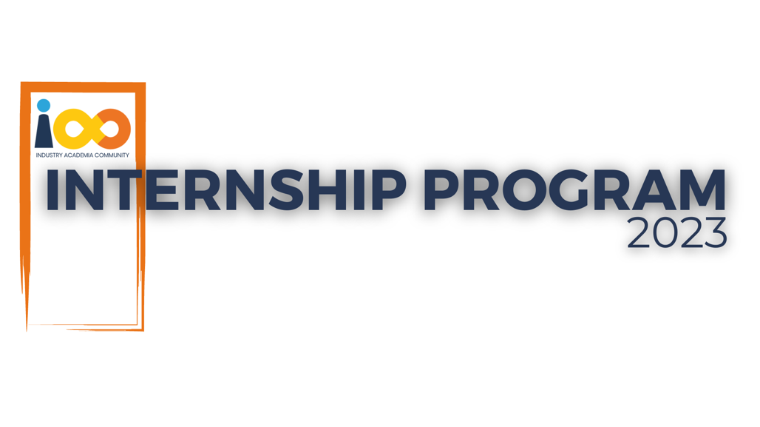

PROJECT REPORT

MACHINE LEARNING  
  
PLACEMENT PREDICTION SYSTEM

|  |  |  |  |
| --- | --- | --- | --- |
| **Created By:** | Santanu Ajit Maity | **Approved By:** |  |
| **Created On:** | 25-05-2024 | **Approved On:** | DD-MMM-YYYY |

Page left blank intentionally

**INDEX**

**1** **PROJECT DETAILS** 2

**2** **SUMMARY** 2

**3** **INTRODUCTION** 2

3.1 Background 2

3.2 Stakeholders 2

3.3 Objectives 2

**4** **METHODOLOGY** 2

4.1 Considerations & Assumption 3

4.2 Approach 3

4.3 Activities 3

**5** **TARGETTED V/S ACHIEVED OUTPUT** 3

**6** **CONCLUSION** 3

**7** **APPENDICES** 4

7.1 Appendix A – Title 4

# **PROJECT DETAILS**

|  |  |  |  |
| --- | --- | --- | --- |
| **Project Name** | Placement Prediction System | | |
| **Project Sponsor** | Cloud Counselage | | |
| **Project Manager** |  | | |
| **Start Date** | 04-02-2024 | **Completion Date** | 04-06-2024 |

# **SUMMARY**

This report outlines the methodology, objectives, and outcomes of a project aimed at predicting the placement of students using a dataset comprising information on 3000 students. After data cleaning, 2500 records were retained for analysis. The predictive algorithm achieved an accuracy of 91%.

# **INTRODUCTION**

## Background

The project originated from the problem statement of predicting student placement, identified through requirement elicitation meetings. Discussions highlighted the need for a predictive model to assist educational institutions in understanding student placement dynamics.

## Stakeholders

Stakeholders involved in this project include educational institutions, students, and potential employers. Educational institutions seek insights into factors influencing student placement, while students and employers benefit from improved placement outcomes.

## Objectives

The objectives outlined in the Project Charter were to develop a predictive model for student placement and achieve a high level of accuracy. These objectives have been successfully met, with a 91% accuracy rate achieved through the implemented algorithm.

# **METHODOLOGY**

## Considerations & Assumption

Constraints such as limited data availability and the need for simplifying assumptions were considered. Assumptions were made regarding the relevance of various features in predicting student placement, based on domain knowledge and preliminary analysis.

## Approach

A structured approach was adopted, focusing on data preprocessing, feature selection, algorithm selection, model training, and evaluation. This approach ensured a systematic workflow from data collection to model deployment.

## Activities

Activities performed included data cleaning, exploratory data analysis, feature engineering, model selection (such as logistic regression, decision trees, or neural networks), model training, hyperparameter tuning, and model evaluation using cross-validation techniques.

# **TARGETTED V/S ACHIEVED OUTPUT**

The targeted output in the project plan was to achieve a predictive model with an accuracy rate exceeding 85%. This target was successfully surpassed, with the implemented algorithm achieving a remarkable accuracy of 91%. Deviations from the project plan were minimal and did not significantly impact the overall outcomes.

# **CONCLUSION**

The developed predictive model for student placement holds significant value for stakeholders, providing insights into factors influencing placement outcomes. Future scope includes refining the model with additional data sources and exploring advanced machine learning techniques to further improve accuracy and predictive capabilities.

# **APPENDICES**

## Appendix A – Title

<Add component table as required>